**Basic Statistics**

1. What does the test statistic tell you?
   1. **It indicates how many standard errors a point estimate lies from the expected null hypothesis population value.**
   2. It's another word for the p-value.
   3. It indicates whether you should use z- or t-distribution to calculate probability.
   4. It indicates how far from the actual population value your sample mean lies.
2. In a group of students 25% are enrolled in physics, 23% in sociology, 17% in chemistry, 14% in political science, 12% in anthropology, and 9% in math. You are going to select an individual from the group of students. The probability of event A is equivalent to the probability that you select someone who studies social science (sociology, political science and anthropology) or physics. What is the probability of the event A’s complement?
   1. 0.51
   2. **0.26**
   3. 0.49
   4. 0.74
3. Assume your null hypothesis is μ = 6. In your sample you find a value that is lower than 6. Is it 'easier' to reject the null hypothesis with a one-tailed or two-tailed test?
   1. **A one-tailed test.**
   2. A two-tailed test.
   3. This depends on the level of significance.
   4. This depends on the P value.
4. Someone makes the following assertion: if the sample becomes larger, then the standard deviation becomes smaller. Which of the following statements is correct?
   1. This assertion does not apply to any distribution.
   2. This assertion always applies to all distributions
   3. This assertion always applies to the sample distribution and the sampling distribution.
   4. **This assertion always applies to the sampling distribution.**
5. The largest number of Oscars received by a film in year X was 4. This was different in previous years. Below is a probability distribution for the number of Oscars per Oscar winning film. What is the standard deviation of this distribution?

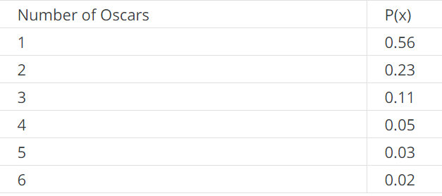

* 1. 1.82
  2. **1.19**
  3. 6
  4. 1.32

1. You draw a sample from the population of a town (n = 312) and find that of this sample, 23% are highly educated and 27% are low-educated. What is the 80% confidence interval for the proportion of highly educated people in this town?
   1. (0.21, 0.25)
   2. **(0.20, 0.26)**
   3. (0.25, 0.29)
   4. (0.23, 0.27)
2. What type of table is shown below?

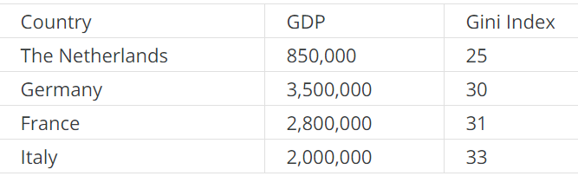

* 1. **Data matrix**
  2. Cross table
  3. Frequency table
  4. Scatterplot

1. You know that there is a strong correlation between the consumption of ice cream and body weight. The Pearson's r = 0.78. You also know that the average consumption of ice cream per week is five grams with a standard deviation of 1.5 grams. The average weight is 65 kg with a standard deviation of 15 kg. What is the formula of the regression line?
   1. ŷ = 7.8 + 26x
   2. ŷ = 0.078 - 502x
   3. ŷ = -502 + 0.078x
   4. **ŷ = 26 + 7.8x**
2. See the sample space below. What is the probability of event B occurring, given that event A has occurred?

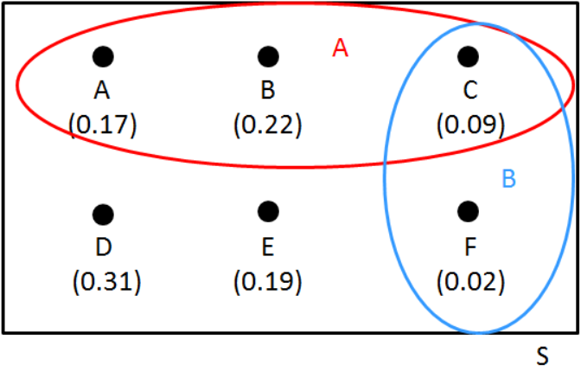

* 1. 0.09
  2. 0.23
  3. 0.82
  4. **0.19**

1. What is a probability?
   1. **The proportion of times that something will occur in the long run.**
   2. An uncertainty.
   3. The number of times that something occurs in an experiment.
   4. A P-value
2. 25% of all students find this BS exam difficult. You select four random students. What is the probability that exactly two of them find this exam difficult?
   1. 0.07
   2. **0.21**
   3. 0.02
   4. 0.06
3. Various forms of bias can occur when we select a sample. What is sampling bias?
   1. If not everyone in the sample actually participates in the research.
   2. If not everyone in the population has an equal chance to enter the sampling frame.
   3. If not everyone in the sample belongs to the population.
   4. **If not everyone in the sampling frame has an equal chance to get into the sample.**
4. Variable A is normally distributed with μ = 12.30 and σ = 3.11. What is the probability that a randomly selected case will have a score of less than 14?
   1. 0.88
   2. 0.29
   3. **0.71**
   4. 0.12
5. A random sample of 61 Basic Statistics students were asked what they thought of statistics on a scale of 0 (very stupid) to 100 (very nice). Interestingly, students seem to find statistics quite nice: the sample mean equals 83. The sample standard deviation equals 7. We know that the standard deviation in the population (all BS students) is 8. Calculate the 90% confidence interval.
   1. (81.53, 84.47)
   2. (81.24, 84.76)
   3. **(81.32, 84.68)**
   4. (80.99, 85.01)
6. You know that for variable A μ = 1400 and σ = 300. You also know that the variable is normally distributed. You decide to change the scores of this variable into z-scores. What is the mean and standard deviation of this new distribution?
   1. **Mean = 0, standard deviation = 1.**
   2. Mean = 1400, standard deviation = 300.
   3. Cannot be calculated on the basis of this information.
   4. Mean = 1400, standard deviation = 1.
7. Ten students resit the Basic Statistics exam. Their final grades are: 4, 4, 2, 9, 7, 9, 6, 4, 7, 8. What is the interquartile range?
   1. 2
   2. 8
   3. **4**
   4. 7
8. Which of the following is **not** the explained variance?
   1. The degree to which the regression equation of X and Y is better at predicting the dependent variable than the average of Y.
   2. **The percentage of variance in Y that is explained by the mean of X.**
   3. The percentage of the variance in Y which is explained with the regression equation.
   4. The Pearson r squared.
9. Look at the following cross table of two ordinal variables. Is there a correlation between variable A and B?

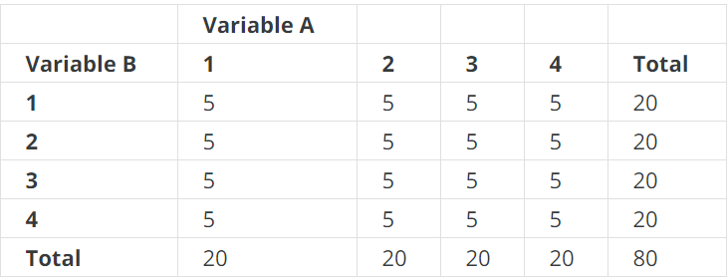

* 1. Yes, there is a negative correlation.
  2. Yes, there is a positive correlation.
  3. Cannot be seen from the table.
  4. **No, there is no correlation.**

1. Look at the table below. Calculate the Pearson's r.

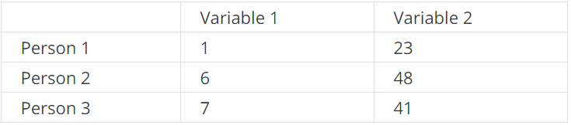

* 1. 0.71
  2. 0.81
  3. **0.91**
  4. 0.61

1. Based on a random sample of n = 2345, the 95% confidence interval of variable X is (7.25, 9.12). You expect that the mean in the population is different from 7 at α = 0.05. What can you conclude?
   1. Nothing, because you have not enough data to determine that.
   2. **The value in the population is indeed different from 7.**
   3. You cannot reject the null hypothesis.
   4. This confidence interval is wrong.
2. Which of the following statements about the regression line is **not correct?**
   1. The constant indicates the place where the regression line crosses the Y-axis.
   2. **The regression line is the line of which the sum of the residuals is the smallest.**
   3. The regression line can run horizontally.
   4. The regression coefficient is the change in the Y value with 1 unit increase in the X value.
3. You’re going to draw a random sample of professional football players because you want to know what percentage have completed high school. You want to have a margin of error of up to 0.03 at a confidence level of 90%. How big should your sample be?
   1. Minimum 1068
   2. Minimum 748
   3. Minimum 456
   4. At least 30
4. 81 random elementary schools were asked for their average exam scores (sample mean = 535, sample standard deviation = 7). Calculate the 98% confidence interval.
   1. **(533.15, 536.85)**
   2. Not possible to calculate based on this information.
   3. (533.41, 536.59)
   4. (528.00, 542.00)
5. A type I error means that:
   1. The null hypothesis is true, and you do not reject the null hypothesis.
   2. **The null hypothesis is true, and you reject the null hypothesis.**
   3. The null hypothesis is false, and you reject the null hypothesis.
   4. The null hypothesis is false and cannot reject the null hypothesis.
6. You know that the heights of four people are: 156 cm, 184 cm, 172 cm and 165 cm. What is the standard deviation?
   1. 28
   2. 10.23
   3. 139.58
   4. **11.81**
7. Last year the mean turnover of a group of companies was 434,000 euro. You have good reasons to expect that this year’s turnover will be higher. Your null hypothesis is therefore: μ = 434,000. Your alternative hypothesis is: μ > 434,000. You randomly sample 101 companies from the population. The sample mean turns out to be 450,000 euro, with a standard deviation of 100,000 euro. Calculate the test statistic. Which of the following statements is correct?
   1. You do not reject the null hypothesis at α = 0.05, and not at α = 0.10.
   2. You reject the null hypothesis at both α = 0.05 and α = 0.10.
   3. You reject the null hypothesis at α = 0.05, but not at α = 0.10.
   4. **You reject the null hypothesis at α = 0.10, but not at α = 0.05.**
8. Film critics gave the film Basic Statistics: The Movie an average rating of 8.1 (on a scale of 0-10). The standard deviation is 0.7. You drew a random sample of n = 56 from all film critics and asked them to rate the film Basic Statistics: The Movie with a number. What is the probability that the average rating in the sample is greater than 8.0?
   1. 14%
   2. 44%
   3. 56%
   4. **86%**
9. You draw a sample from the population of Dutch voters. You do this by randomly selecting 10 voters from each municipality. What kind of sample is this?
   1. Cluster random
   2. Snowball
   3. Convenience
   4. **Stratified random**
10. What does the 95% confidence interval tell us?
    1. In 95% of cases when we sample from a population, the sample mean falls within the interval: sample mean ± 1.96 * standard deviation of the sampling distribution.
    2. In 95% of cases when we sample from a population, the sample mean falls within the interval: sample mean ± 1.64 * standard deviation of the sampling distribution.
    3. **In 95% of cases when we sample from a population, the population mean falls within the interval: sample mean ± 1.96 * standard deviation of the sampling distribution.**
    4. In 95% of cases when we sample from a population, the population mean falls within the interval: sample mean ± 1.64 * standard deviation of the sampling distribution.
11. What is a characteristic of the t-distribution?
    1. **A t-value that is multiplied with a standard error is equal to the margin of error for a confidence interval of a mean.**
    2. The t distribution has a mean of one.
    3. The t-distribution approaches the normal distribution if it has a large standard deviation.
    4. The t-distribution has the same shape as the normal distribution.